**Hotel Management Software Development Project**

**[Deliverable 4: Use Stories]**

**OCTOBER 19th, 2022**

**Client Information :   
Hôtel Manoir Ramezay – Vivian (Proprietor)**   
*492, rue Claude de Ramezay (Route 227),   
Marieville (Québec) J3M 1J6*  
Telephone : (450) 460-3251 | E-mail: [info@manoirramezay.com](mailto:info@manoirramezay.com)



**CERTIFICATIONS**:   
I, Red Team LEADER, **Li Yu # 2295012**, certify that I have contributed to this deliverable.

Date: 2022-10-19

I, Red Team MEMBER, **Patrick Larocque # 0879202**, certify that I have contributed to this deliverable.

Date: 2022-10-19

I, Red Team MEMBER, **Gerasimos Vlassopoulos # 2295049**, certify that I have contributed to this deliverable.

Signature: 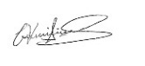 Date: 2022-10-19

I, Red Team MEMBER, **Murat Osmonov # 219501**, certify that I have contributed to this deliverable.

Signature: Date: 2022-10-19

I, Red Team MEMBER, **Chi-Tao Li # 9730157**, certify that I have contributed to this deliverable.

Signature:  Date: 2022-10-19

|  |
| --- |
| Table of Contents |
| 1. **Statement of Prior Work ….………………………………………………3** |
| 1. **Introduction …………….……………………………………....….……... 4** |
| 1. **Executive Overview ……….………………...……………….……...……. 4** |
| 1. **Summary Description of the Client …..…………………….……...……. 5** |
| 1. **Description of the Business Problem ………….…………………….…... 6** |
| 1. **Narrative description of the future information system ……………….. 9** |
| 1. **Appendix 1 ……………………………………………..……….………..... 9** |
| 1. **Appendix 2 ………….……………………...…………………………...... 11** |
| 1. **Appendix 3 – User story map ………………………………………….... 12** |
| 1. **References/Bibliography ……..………..…..…………………………….. 14** |

**I. Statement of Prior Work**

The work herein is possible in part due cumulative learning assignments and projects undertaken in the past, as part of the team’s Software Development curriculum. As such, some of the ideas or technical skills used in this project originate partially from prior work. The table below lists past projects undertaken by members of the Red Team, which may contribute in part to elements found in the scope of this project.

|  |  |  |
| --- | --- | --- |
| Past Projects | Tools Used | Contributor(s) |
| Mock-ups for personal websites, Application Dev 1 | Adobe Photoshop, Cava, Figma | All membres |
| Simulation Program | Java and Java Swing | Chi-Tao Li |
| Car Rental System | MS SQL Server | All members |
| Inventory Management System | Apache Derby Database, Java, and Java Swing | Patrick Larocque |
| Issue Tacker | C#, Google API, .NET, Firebase | Patrick Larocque |
| Added Prior Works  used for this deliverable | Tools Used | Contributor(s) |
| Deliverable 1 Report | MS Word, Instagantt.com (for Gantt Chart) | All members |
| Deliverable 2 Report | MS Word | All members |
| Database course | Draw.io, Lucidchart | All members |
| Deliverable 3 Report | MS Word, Draw.io | All members |
|  |  |  |
|  |  |  |

**II. Introduction**

This document is the fourth deliverable in a series of reports aimed at the assessment and diagnosis of business problems affecting Manoir Ramezay. On this deliverable the red team focused on using all the user stories writing techniques after meetings with our client to identify a new business information system that meets our client's needs and something we can implement completely.

**III. Executive Overview**

The following document outlines the red team’s efforts and activities aimed at many user stories related to our client, Manoir Ramezay regarding the future information system. After discussing the features, they would like to have in their new system and a few things that they would like to improve. Then, we wrote them down in detail in order to get as much information as possible.

Later, after another meeting, we were then able to write, with our client, some user stories. These stories contain requirements that would help implement an information system for their business and meet their needs. After writing these user stories, we then created, also with the client, acceptance tests for each user story that would evaluate and verify their stories. After completion of both the user stories and their tests, we then created a user story map which we arranged to help understand how the system will function.

Lastly, after all appendix is complete, we summarize what is described in the user stories to be read like a story in Narrative description of the future information system, also update our client’s summary description and our client’s business problem, to illustrate more of what we’ve learned about our client and changes that have been made.

**IV. Summary Description of the Client**

Manoir Ramezay is a 3-star hotel located in Marieville purchased by its current owners in 2018. The owners are first time hotel operators and are of Chinese ethnicity. They immigrated from China to Canada with their two children. During the four years they have been operating the hotel, their business has been consistently growing. The hotel offers 9 standard rooms, 5 suites, an event space, a restaurant, which currently operates as a rental kitchen, and a spa/hot-tub area, which also operates as a rental service, due to COVID restrictions. The business has a website, which includes features typical for a hotel business, including a landing page which introduces the hotel along with images of its amenities, pages that describe the services offered. Guests can make a reservation through their website, as well as the third-party platforms, namely Expedia, Booking.com, Hotels.com and Priceline.com, along with walk-in reservations or by phone. Their primary method of bookkeeping consists of keeping a record of reservations inside of a physical ledger. This ledger is updated each time a booking is made, through any of the various booking channels. They may also print booking confirmations they receive via email for the purpose of bookkeeping. They have kept most of the legacy systems in place, from when the business was purchased 4 years ago. They have not modified the website, other than for the purposes of COVID updates, and much of the management practices have remained unchanged. Their business has grown since it was acquired, and the staff at Manoir Ramezay has voiced their desire to improve and modernize their management systems to solve the business problems they see themselves facing. Regarding the staff’s computer skills, the owners have working knowledge of Microsoft’s Office suite, along with a basic understanding of navigating the web, and using email services. The accountant uses QuickBooks to manage the finances of the business. The cleaning staff do not use any software tools on a day-to-day basis to complete their duties. Management has expressed a willingness to learn any new software tools, should it help them operate their business and solve their current business problems.

We must add something in this section I think, maybe something for our conversation with the owners and something about our visit with them.... small paragraph

**V. Description of the Business Problem**

The hotel doesn’t have an efficient system in place to keep track of room availability across available booking channels. When a room is booked through one of their platforms, front- desk staff must update a physical ledger or print out a confirmation from a third-party platform to have a unified running tally of past reservations. Front desk staff must then manually change room availabilities across all other platforms to avoid duplicate bookings and to reflect the actual availability. This is a very inefficient process, especially when the hotel is busy, during the summer months. The front-desk staff is often preoccupied with assisting on-site clients and fulfilling requests, so much so that they are unable to keep up with the current methods of data entry. The potential for double bookings, and overworked front-desk staff may lead to poor experience for the client, leading them to choose another establishment in the future. Moreover, if a repeat client returns to the hotel to book a room, the front-desk staff must reference the physical ledger or paperwork to find their personal information or preferences (if any were noted). This often leads to the client having to repeat much of the same information that was given during prior visits.

As it stands, the current business problem has to do with efficient booking management. The current process is inefficient, leading to inaccurate room tallies, overworked front-desk staff, an inability to answer client questions and the potential for poor client experience as a result. Writing down all guests’ information on paper is a slow and error prone process and appears to be a pain point with respects to the hotel’s day to day operations. Booking and client information is spread across many tools and platforms, each needing to be cross-referenced every time a booking is made. This creates a bottleneck for the business if it wishes to continue growing.

Front-desk employees need to be able to quickly verify guest’s personal information for the check-in and check-out process to be as seamless as possible, stay in control of their bookings and automate repetitive tasks. As well need to have a real time calendar with customizable colours, quick adding and modification of reservations, returning customer base, multiple currency invoicing in the same place. Group bookings feature with bulk setup and quickly adoptable guest details. Easy group bookings search and modifications and inventory updates across every system and booking platform they're connected to.

**VI. Narrative description of the future information system**

Given that third party booking platforms provide inherent discoverability for the hotel, along with familiar and immediate ways for potential guests to book through the platforms they are familiar with, the proposed information system will only be a business facing tool to be used by hotel staff to retrieve up-to-date room availabilities through an API. The system will also allow hotel staff to complete reservation requests made by guests booking directly through the hotel, by phone, email, walk-in or through the hotel’s website.

The Red Team has identified two primary roles relevant to the system. The first role is the receptionist, who will function as a generic user. The receptionist needs basic authorization, sufficient to create, modify and delete reservations, as well as browse, and update availabilities. The second role is a manger role. The manager will have admin privileges within the system. In addition to being able create, modify, and delete reservations, as well as read and update availabilities, the administrator will be able to create, read, update, and delete users on the system. The administrator will be able to manage user privileges, and the scope of their access to the system.

Both the user and administrator will begin at a login screen, where they will enter their usernames and password. Should they enter valid credentials, they will be logged in, and taken to the home screen with account privileges matching their account credentials. Should they enter invalid credentials, they will be shown an error message. Upon a successful login, the system will initiate API calls to retrieve up-to-date availabilities from third party booking platforms. Once at the home screen the user and the admin both will see some statistics amount the day’s availabilities. The user will have the option to navigate to a reservation’s menu, allowing the user to create a new reservation. Initiating a new reservation will also necessitate payment functionality. They may navigate to a calendar view of the month’s current availabilities. Or a list view showing either past, current, or future reservations. From here the user may be able to search, modify, or delete reservations. There will be a button to refresh availabilities, which will make a series of new API calls to retrieve the most up-to-date booking history. The administrator will have access to the same functionality, however, they will additionally be able to navigate to a user’s tab, where they will be able to create, read, update, or delete users. At any moment the user and the administrator both should be able to exit the application by clicking a button.

**VII. Appendix 1**

**User Story 1**

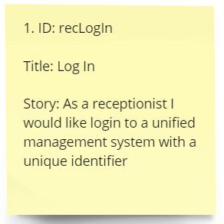

**User Story 2**

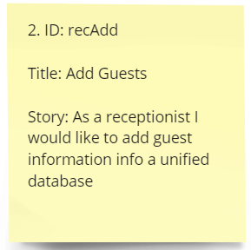

**User Story 3**

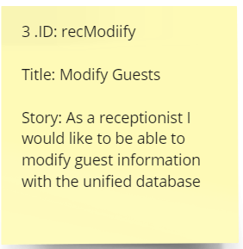

**User Story 4**

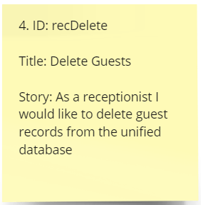

**User Story 5**

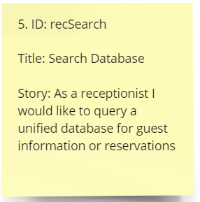

**User Story 6**

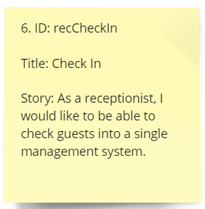

**User Story 7**

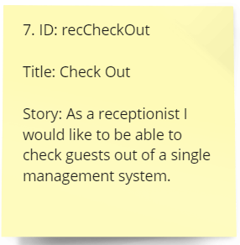

**User Story 8**

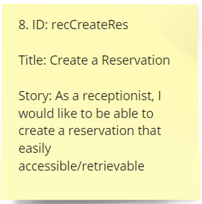

**User Story 9**

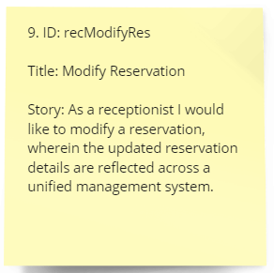

**User Story 10**

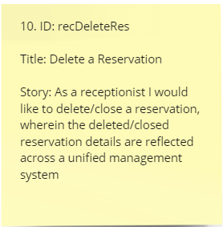

**User Story 11**

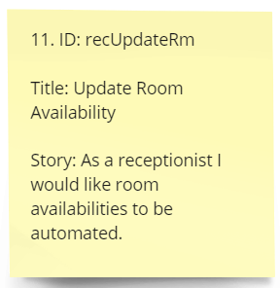

**User Story 12**

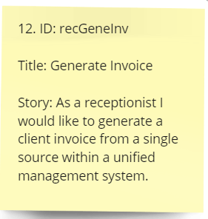

**User Story 13**

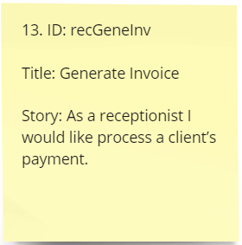

**User Story 14**

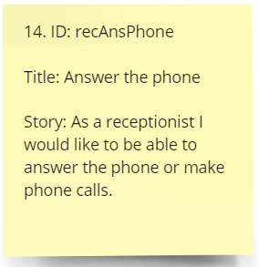

**User Story 15**

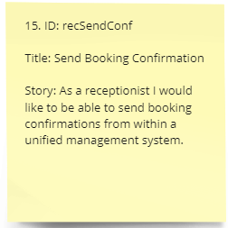

**User Story 16**

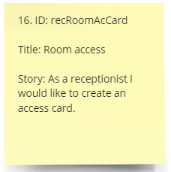

**User Story 17**

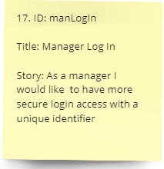

**User Story 18**

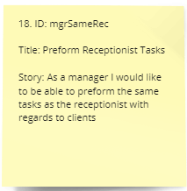

**User Story 19**

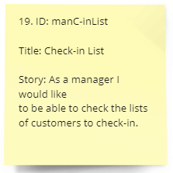

**User Story 20**

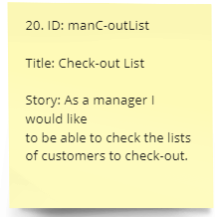

**User Story 21**

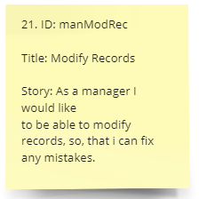

**User Story 22**

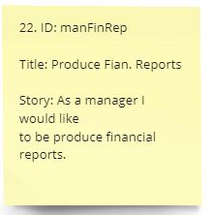

**User Story 23**

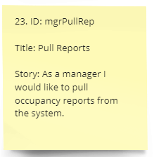

**User Story 24**

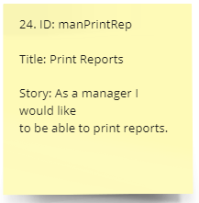

**User Story 25**

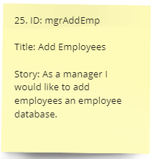

**User Story 26**

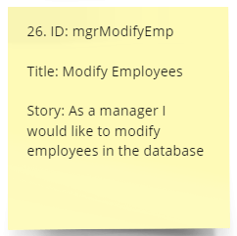

**User Story 27**

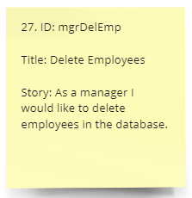

**User Story 28**

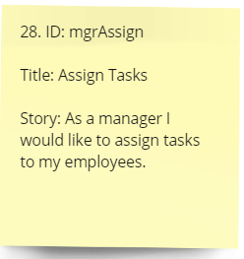

**User Story 29**

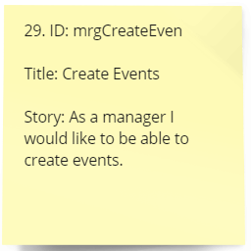

**User Story 30**

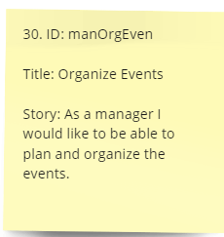

**VIII. Appendix 2**

**User Story Tests 1**

Scenario: log in

1a. Given that the user is the receptionist

When input a correct unique ID

Then he/she has full access to the system.

1b. Given that the user is the receptionist

When input an incorrect ID

Then he/she cannot have access to the system.

**User Story Tests 2**

Scenario: Add Guests

2a Given that the user is the receptionist

When input new guests’ details into the system

Then the user successfully adds to the database.

2b. Given that the user is the receptionist

When input the existing guests’ detail

Then the user is not allowed to add to the database.

**User Story Tests 3**

Scenario: Modify Guest

3a Given that the user is the receptionist

When input the guests’ details into the system

Then the user successfully modifies in the database.

3b. Given that the user is the receptionist

When input the non-existing guests’ detail into the system

Then the user cannot modify in the database.

**User Story Tests 4**

Scenario: Delete Guests

4a Given that the user is the receptionist

When input the existing guests’ details into the system

Then the user successfully deletes from the database.

4b. Given that the user is the receptionist

When input the non-existing guests’ detail into the system

Then the user cannot delete from the database.

**User Story Tests 5**

Scenario: Search Database

5a. Given that the user is the receptionist

When input a correct unique ID

Then he/she can search within the database.

5b. Given that the user is the receptionist

When input an incorrect ID

Then he/she cannot with in the database.

**User Story Tests 6**

Scenario: Check In

6a. Given that the user is the receptionist

When he/she has full access to the system

Then he/she can check in the guest.

6b. Given that the user is the receptionist

When he/she does not have full access to the system

Then he/she cannot check in the guest.

**User Story Tests 7**

Scenario: Check Out

7a. Given that the user is the receptionist

When he/she has full access to the system

Then he/she can check out the guest.

7b. Given that the user is the receptionist

When he/she doesn’t have full access to the system

Then he/she cannot check out the guest.

**User Story Tests 8**

Scenario: Create a Reservation

8a. Given that the user is the receptionist

When he/she has full access to the system

Then he/she can create a reservation.

8b. Given that the user is the receptionist

When he/she does not have full access to the system

Then he/she cannot create a reservation.

**User Story Tests 9**

Scenario: Modify Reservation

9a. Given that the user is the receptionist

When he/she has full access to the system

Then he/she can modify a reservation.

9b. Given that the user is the receptionist

When he/she doesn’t have full access to the system

Then he/she cannot modify a reservation.

**User Story Tests 10**

Scenario: Delete a Reservation

10a. Given that the user is the receptionist

When he/she has full access to the system

Then he/she can delete a reservation.

10b. Given that the user is the receptionist

When he/she doesn’t have full access to the system

Then he/she cannot delete a reservation.

**User Story Tests 11**

Scenario: Update Room Availability

11a. Given that the user is the receptionist

When he/she has full access to the system

Then he/she can update the room availability.

11b. Given that the user is the receptionist

When he/she doesn’t have full access to the system

Then he/she cannot update the room availability.

**User Story Tests 12**

Scenario: Generate Invoice

12a. Given that the user is the receptionist

When he/she has full access to the system

Then he/she can generate a client invoice.

12b. Given that the user is the receptionist

When he/she doesn’t have full access to the system

Then he/she cannot generate a client invoice.

**User Story Tests 13**

Scenario: Client’s payment

13a. Given that the user is the receptionist

When he/she has full access to the system

Then he/she can process a client’s payment

13b. Given that the user is the receptionist

When he/she doesn’t have full access to the system

Then he/she cannot process a client’s payment.

**User Story Tests 14**

Scenario: Answer the phone

14a. Given that the user is the receptionist

When he/she answers a phone call and the customer wants to make a reservation

Then he/she is able to add the reservation to the system.

14b. Given that the user is the receptionist

When he/she answers a phone call and the customer wants to an electronic invoice

Then he/she cannot generate an electronic invoice.

**User Story Tests 15**

Scenario: Send Booking Confirmation

15a. Given that the user is the receptionist

When the customer wants to check in

Then he/she can create the access card through the system.

15b. Given that the user is the receptionist

When the customer loses the access card

Then he/she replace the access card via the system.

**User Story Tests 16**

Scenario: Room access

16a. Given that the user is the receptionist

When the customer has successfully booked online

Then he/she can send booking confirmation via the system.

16b. Given that the user is the receptionist

When the manager requests all the booking confirmations

Then he/she can send all the confirmations through the system.

**User Story Tests 17**

Scenario: Manager Log In

17a. Given that the user is the manager

When input a correct unique ID

Then he/she has full access to the system.

17b. Given that the user is the manager

When input an incorrect ID

Then he/she cannot have access to the system.

**User Story Tests 18**

Scenario: Browse Room

18a. Given that the user is the manager

When he/she has the access to the system

Then the manager can perform the same task as a receptionist.

18b. Given that the user is the manager

When he/she does not have the access to the booking system

Then the manager can perform the same task as a receptionist.

**User Story Tests 19**

Scenario: Check-in List

19a. Given that the user is the manager

When he/she has access to the system

Then the manager can check the lists of customers that check-in.

19b. Given that the user is the manager

When he/she does not have access to the system

Then the manager cannot check the lists of customers that check-in.

**User Story Tests 20**

Scenario: Checkout List

20a. Given that the user is the manager

When he/she has access to the system

Then the manager can check the lists of customers that checkout.

20b. Given that the user is the manager

When he/she does not have access to the system

Then the manager cannot check the lists of customers that checkout.

**User Story Tests 21**

Scenario: Modify Records

21a. Given that the user is the manager

When he/she has access to the system

Then the manager can modify records, so that he/she fix can any mistakes.

21b. Given that the user is the manager

When he/she does not have access to the system

Then the manager cannot modify records, so that he/she fix can any mistakes.

**User Story Tests 22**

Scenario: Produce Financial Reports

22a. Given that the user is the manager

When he/she has access to the system

Then the manager can produce financial reports.

22b. Given that the user is the manager

When he/she has does not have access to the system

Then the manager cannot produce financial reports.

**User Story Tests 23**

Scenario: Pull Reports

23a. Given that the user is the manager

When he/she has access to the system

Then the manager can pull occupancy reports.

23b. Given that the user is the manager

When he/she has does not have access to the system

Then the manager cannot pull occupancy reports.

**User Story Tests 24**

Scenario: Print Reports

24a. Given that the user is the manager

When he/she has access to the system

Then the manager can print reports.

24b. Given that the user is the manager

When he/she has does not have access to the system

Then the manager cannot print reports.

**User Story Tests 25**

Scenario: Add Employees

25a. Given that the user is the manager

When he/she has access to the system

Then the manager can add employee.

25b. Given that the user is the manager

When he/she has does not have access to the system

Then the manager cannot add employee.

**User Story Tests 26**

Scenario: Modify Employees

26a. Given that the user is the manager

When he/she has access to the system

Then the manager can modify employee.

26b. Given that the user is the manager

When he/she has does not have access to the system

Then the manager cannot modify employee.

**User Story Tests 27**

Scenario: Delete Employees

27a. Given that the user is the manager

When he/she has access to the system

Then the manager can delete employee.

27b. Given that the user is the manager

When he/she has does not have access to the system

Then the manager cannot delete employee.

**User Story Tests 28**

Scenario: Assign Tasks

28a. Given that the user is the manager

When he/she has access to the system

Then the manager can assign tasks to the employees.

28b. Given that the user is the manager

When he/she has does not have access to the system

Then the manager cannot assign tasks to the employees.

**User Story Tests 29**

Scenario: Create Events

29a. Given that the user is the manager

When he/she has access to the system

Then the manager can create events.

29b. Given that the user is the manager

When he/she has does not have access to the system

Then the manager cannot create events.

**User Story Tests 30**

Scenario: Organize Events

30a. Given that the user is the manager

When he/she has access to the system

Then the manager can organize events.

30b. Given that the user is the manager

When he/she has access to the system

Then the manager cannot organize events.

**IX. Appendix 3**

In our opinion, the best tool for mapping user stories is Miro is a platform that enables whiteboard collaboration, distributed teams to work together effectively, from brainstorming with digital notes to planning and managing agile workflows. User Story Mapping is one of the patterns it supports.

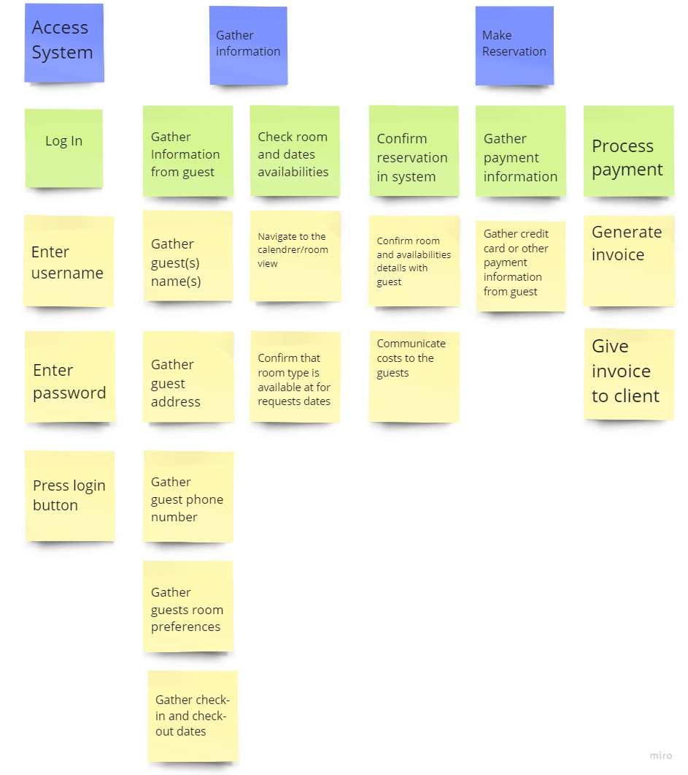

**X. References**